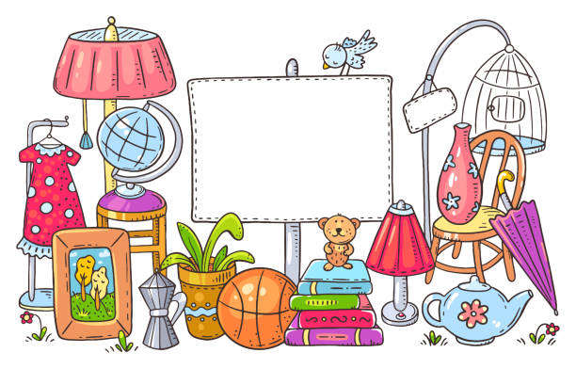
[Grab your reader’s attention with a great quote from the document or use this space to emphasize a key point. To place this text box anywhere on the page, just drag it.]rummage Sale

1st Annual
Rummage Sale
1449 4th Avenue SE, Rochester, MN 55904
September 7, 8 and 9, 2023
9am-3pm
All Proceeds Benefit

For more information contact Damascus Way @ 507-292-1700 or nick.abbott@damascusway.com

